**Implementation of Preoperative Spinal Injection in Combination with  
 General Anesthesia and Its Effect on Pain Scores and Inpatient  
 Opioid Consumption in Robotically Assisted Hysterectomies**  
Chrissy Wilson

Ban 530

Applications in Business Analytics

Telephone: 910-515-0277

Email: cs9435@uncw.edu

Instructor: Dr. Rebecca Scott

**Implementation of Preoperative Spinal Injection in Combination with General Anesthesia and Its Effect on Pain Scores and Inpatient Opioid Consumption in Robotically Assisted Hysterectomies**

With approximately 600,000 hysterectomies being performed annually in the United States, it is the second most frequently performed surgical procedure, after cesarean section, for U.S. women who are of productive age (Flinn, 2019). Over the past 40 years, scientists and surgeons have revolutionized this complex surgery from a traumatic/high-risk open procedure to a minimally invasive surgery that is either performed laparoscopically or robotically assisted with the Da Vinci Robot. With the advanced surgical technology, women showed better outcomes such as less surgical trauma, a lower postoperative infection rate, improved cosmetics as the incision sites are minimal, and reduced hospital stay. Nonetheless, the pain associated with a hysterectomy was excruciating, no matter what surgical approach was chosen. The patients received a great amount of medications after surgery to relief the pain. In order to decrease postoperative pain in hysterectomy patients, the anesthesia department at New Hanover Regional Medical Center (NHRMC) has started combining general anesthesia (GA) with a spinal block in 2018. However, the implementation of SA is still not a unisonous standard across the entire anesthesia and gynecology department causing increased pain and a longer recovery time to some women.  
 The purpose of this project is to evaluate the impact of combining SA (Spinal anesthesia) with general anesthesia to achieve improved surgical outcomes in women undergoing a robotically assisted hysterectomy. A retrospective study designed to enhance the quality of patient care by reducing pain scores, opioid use and shortening length of hospital stays postoperatively.

## **Methods**

The data used in this study consists of 554 women who received a robotic hysterectomy in 2019 at NHRMC due to various reasons. The following metrics were pulled from New Hanover Regional Medical Center’s (NHRMC) medical records system, Epic, and collected: patient’s age, physical health status, procedure description, date admitted, date discharged, comorbidities, and narcotics that have been administered intra- and postoperative. The variables of interest in the dataset are the following:

* **Block Anesthesia** – what type of anesthesia the patient received
* **LOS/Days** – Patient’s Length of Stay at the hospital
* **DOS** – Day of surgery pain score using the 0 to 10 Numerical Rating Scale
* **POD1** – First post-operative day pain score using the 0 to 10 Numerical Rating Scale
* **Dilaudid** – Yes if Dilaudid was given postoperatively, No if otherwise

**Data Cleaning and Preparation**

The data collected in this study was cleaned and prepared using the machine learning tool JMP Pro 15. Duplicates, missing values and irrelevant information were identified and eliminated, which reduced the raw data by nine observations. Furthermore, one patient turned out to be an outlier due to developing major complications unrelated to the gynecological procedure. Initially, each hysterectomy procedure was classified by its surgical approach of either being open, laparoscopic, or robotic. As this study is interested in only robotic hysterectomies, all open and laparoscopic procedures were eliminated. In addition, all 544 robotic surgeries were categorized as either “No block robotic” or “Block robotic”, creating a binary variable that divides the data into patients who received spinal anesthesia pre-operative and patients who did not. Furthermore, JMP Pro 15 was utilized to convert the hours of length of stay into days for easier interpretation and to create an additional binary variable indicating whether a patient received Dilaudid for pain management or not. In addition to data preparation, JMP Pro 15 was also used for the descriptive and predictive analysis of this project, as it provides tools and methods that are easy to use, fast and straight-forward.

**Descriptive Analysis**

The organized and processed dataset was analyzed using JMP’s distribution tool. The average of hospital stay was calculated for patients who received a block and for those who did not. In addition, the average pain score for the day of surgery and the first postoperative day was also documented for each group. Lastly, the percentage of patients receiving Dilaudid was calculated and compared between the two groups. Summary statistics were documented and charts of patient outcomes were created with the use of JMP Pro 15.

This diagram shows that the majority of robotic hysterectomies in 2019 was performed under general anesthesia with the addition of spinal anesthesia preoperative (Robotic). Additionally, the distribution and average length of hospital stay is very similar between both anesthetic approaches. However, examining the women’s pain scores the day of surgery and the first postoperative day, a greater difference between robotic and no block robotic hysterectomies can be recognized. In patients without the preoperative spinal anesthesia, pain scores show an average value of about 5 on the day of surgery and drop to an average of about 4 the following day. In comparison, receiving a spinal block before surgery results in patients reporting an average pain level of approximately 2 with a mode of 0 and the following day looks very similar in pain scores.

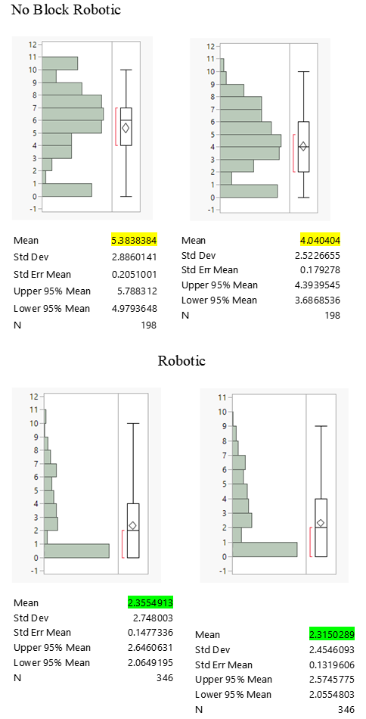  
  
 Last but not least, the distribution and relationship between anesthetic approach and opioid use was examined. The difference in pain scores between block and no-block robotically assisted hysterectomy patients is reflected in the percentage of women receiving Dilaudid to relieve their pain. While only 22% of the 346 women, who received a spinal injection preoperative, displayed opioid use, 63% of the other 198 patients were administered Dilaudid due to their increased pain level.

  
 No Block Robotic Robotic  
 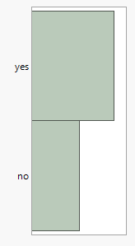 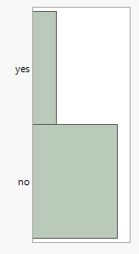

| **Level** | **Count** | **Prob** |
| --- | --- | --- |
| no | 270 | 0.78035 |
| yes | 76 | 0.21965 |
| Total | 346 | 1.00000 |

Pearson’s chi-square test was conducted between the categorical variable of “approach” and the numerical variables “LOS”, “DOS”, “POD1” and “Dilaudid”. As the anesthetic approach and “LOS” did not show a significant difference (p-value= 0.7544), all other numeric variables were statistically significant with a p-value of less than 0.05. Despite the insignificance of “LOS”, the data appears to be a good fit for statistical testing and the project scope.

**Predictive Analysis**  
 Conducting a preliminary descriptive analysis of the hysterectomy dataset has resulted in three response variables of interest. This study will look at the patients’ pain scores the day of surgery (DOS) and the first postoperative day (POD1), as well as, the administration of Dilaudid (Dilaudid) for pain management after the surgery. The software program JMP Pro is utilized to apply linear (Ordinary Least Square, Stepwise, penalized regression, logistic regression) as well as non-linear (random forest, neural networks, boosted trees) prediction methods to estimate a model that will perform best in determining the factors for predicting the effect of preoperative spinal injection in combination with general anesthesia on pain scores and opioid consumption in robotically assisted hysterectomies. In order to achieve an accurate estimate of how predictive models would perform with new, unseen data, cross-validation was employed using JMP Pro 15. The validation column will be used in all of the model estimations. Ultimately, the best model will be chosen by the RSquare, RASE. AAE and/or AUC criteria in the Test data, and results will be interpreted.

**Results**

Initial data analysis showed that the average length of hospital stay does hardly differentiate when comparing patients who received preoperative spinal anesthesia and patients without it. However, the impact of the preoperative spinal injection is tremendous in regard to pain scores and opioid use. Patients who received a spinal block before surgery perceived their average pain level around 2.36 on a scale from 0 to 10, shortly after the procedure. In comparison, patients without a block reported an average pain score of 5.38. Looking at the following day, a slight decrease in pain scores can be recognized for both groups. However, patients who underwent a no-block robotic hysterectomy still presented with a pain score almost twice as high as patients who received a spinal block for postoperative pain management.  
 The prediction method, boosted Neural Network (NN), explained about 37.5% of predicting the effect of a spinal block on the patient’s pain score the day of surgery. It identified the anesthetic approach as the most important variable by conducting variable importance analysis.

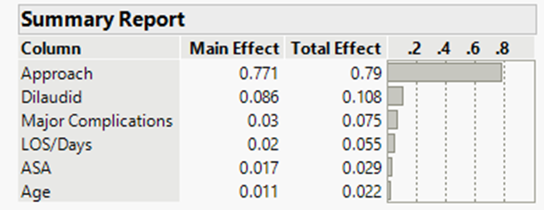

While the administration of Dilaudid comes in second with a total effect of 10.8%, the anesthetic approach dominates the determination of a patient’s pain score after a robotic hysterectomy explaining approximately 80%. Surgical complications, length of stay, physical health status and age have very minimal influence on determining pain scores the day of surgery. When profiling the relationship between each significant individual predictor and the response variable, DOS, the following correlations can be recognized.

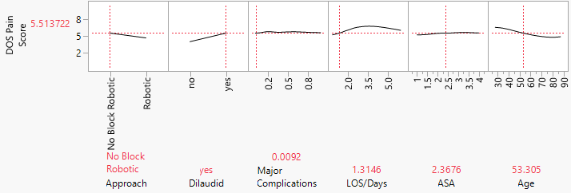

In the graph, a robotically assisted hysterectomy without a spinal block, where the patient required Dilaudid administration, displays a pain score of 5.5. On the contrary, looking at the exact same individual with the exception of implementing a spinal block preoperative and no Dilaudid needed, the patient’s pain score is reduced down to 1.97.

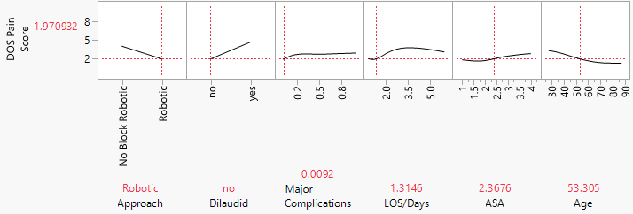

While the anesthetic approach had a tremendous impact on the patient’s pain score right after surgery, pain levels the next day appear to reflect more on the original pain score (DOS) and the age of the patient with a total effect of 36.5% and 28%, respectively.



On the first postoperative day, other variables such as complications during surgery, the patient’s physical health status, comorbidities, etc. may have a little bit more impact on the patient’s pain perception. When profiling the relationship between each significant individual predictor and the response variable, POD1, the following correlations can be recognized.

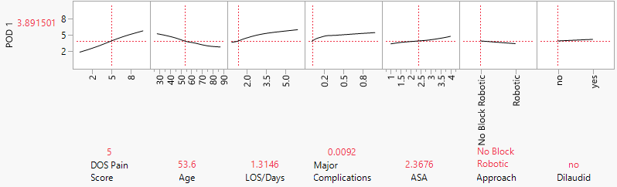

In the graph, a patient example is given for a 53 year old female, who is fairly healthy, experienced no complications during her hysterectomy and reported a pain score of about 1.5. According to the graph, her pain score increased slightly on the first postoperative day, which would be expected due to narcotics and other medications wearing off. Now, looking at the exact same individual with the exception of changing the DOS pain score to 5, a decrease in post-op pain can be seen at 3.9.

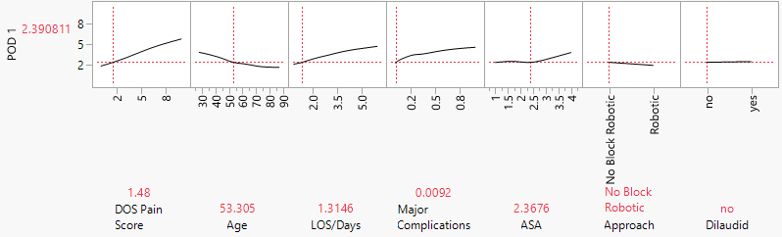

The example also shows that an older woman may report a decrease in pain the next day, whereas a younger woman in her thirties may experience an increase in pain under similar circumstances.   
 Last but not least, the machine learning tool, JMP Pro, chose adaptive Elastic Net as the preferred prediction method to estimate a model that will perform best in determining the factors that will lead to Dilaudid consumption. It shows coefficient values for five out of the seven parameters. The predictors, age and ASA, were dropped by the penalized regression method, meaning that they were considered weak predictors and were therefore eliminated.

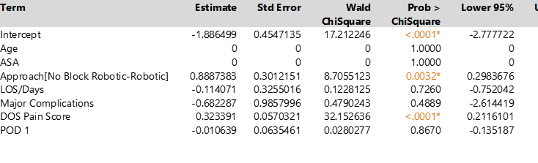

However, in the table it can be recognized that anesthetic approach and DOS pain scores are the only statistically significant parameter estimates with a p-value of less than 0.05. Approach, in this case the no block robotic approach, and DOS pain score show a positive coefficient. Therefore, if the team of providers decides to not use a spinal injection preoperative, the patient is more likely to be administered Dilaudid. Likewise, the greater the patient’s pain the day of surgery, the higher the probability that Dilaudid consumption will take place as a form of pain management.   
The conduction of variable importance analysis has identified a patient’s DOS pain score as the most important variable.

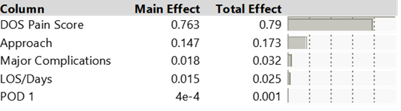

The pain score on the day of surgery explains approximately 80% of opioid consumption after a robotically assisted hysterectomy. Anesthetic approach is the second predictor variable that influences the Dilaudid intake prediction model with a total effect of 17.3%. When profiling the relationship between each significant individual predictor and the response variable of Dilaudid, the following correlations can be recognized.

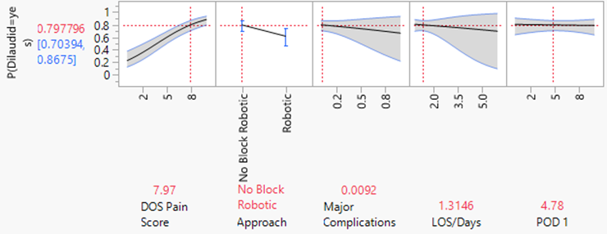

In this graph, a sample is given of a patient with a DOS pain score of about 8, who did not receive a spinal injection preoperative. According to the graph, there is an 80% probability that this patient will consume Dilaudid after surgery. On the contrary, looking at an individual with a DOS pain score of 3, who received a spinal block before surgery, has a 25% chance to require Dilaudid postoperative.

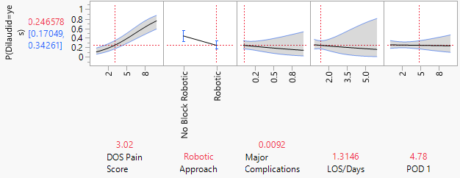

All three of the model estimations show a connection and correlation between a patient’s pain level after robotic hysterectomy surgery, opioid consumption and the anesthetic approach chosen by the surgical providers. It appears that the approach has a tremendous effect on a patient’s pain score shortly after surgery. Women who receive a spinal injection in addition to general anesthesia are more likely to report lower pain scores on the day of surgery and the following day, and are less likely to consume Dilaudid, as milder medications may suffice for pain management. On the contrary, anesthesiologist who do not administer a spinal block preoperative, will more likely have their patients in greater pain after surgery requiring opioids, such as Dilaudid, to manage their pain.

**Conclusion**

The conduction of preliminary descriptive and predictive analytics has led to final recommendations in order to improve the performance of the model in this study. It was concluded that the anesthetic approach and the administration of Dilaudid impact pain scores the day of surgery, whereas the patient’s second pain score on the first postoperative day appears to be more influenced by the initial pain score that was given the day prior and the patient’s age. In regard to the response variable *Dilaudid,* it can be recognized that anesthetic approach and DOS pain scores are the only statistically significant parameter estimates and explain approximately 80% and 17.3% of opioid consumption after a robotically assisted hysterectomy, respectively.   
 Both, the anesthetic approach and DOS pain score, are the most highly significant variables to affect overall pain scores and inpatient opioid consumption in robotically assisted hysterectomies. The objective of this study is to propose an optimization model for minimizing pain scores after conducting a hysterectomy and minimizing the probability of Dilaudid consumption. Based on the following diagrams, the gynecology department can optimize its patient outcomes and patient care quality by adding a spinal block to the patient’s general anesthesia. The decision to leave out a spinal injection is documented by high pain levels and Dilaudid consumption for pain management in the majority of 198 patients. On the contrary, looking at the positive outcomes spinal anesthesia has on DOS pain score and Dilaudid consumption in 346 patients, the anesthesiology and gynecology department could optimize its patient care quality by reducing the number of patients not receiving a spinal block preoperative. The probability of a positive outcome with spinal anesthesia is a lot higher than the alternative. 



In addition to the probabilities of the previous outcomes, the cost of each resource adds excessive value to the decision-making process of anesthetic approach. The average cost of a spinal anesthesia is about $550 which includes an upcharge by the anesthesiologist. In comparison, starting a patient-controlled analgesia (PCA) pump for Dilaudid administration will be an automatic $1000 charge to the patient. Considering both costs, receiving a spinal block with a high probability of no Dilaudid consumption can reduce healthcare costs for the patient tremendously, and therefore lead to higher patient satisfaction.   
 Identifying areas of concern will have an impact on the ultimate outcome and, therefore, aid the decision-making process, as well. The greatest challenge in health care is that every patient is individual and may enter this surgical procedure from a different start line. Patients will differ in their perception of pain intensity depending on their pain threshold they have established over the years. Patients with more comorbidities and a lower physical health status could be at a disadvantage compared to otherwise healthy individuals, as their recovery may take longer due to prolonged or chronic pain. Patients with chronic opioid exposure tend to experience pain on a higher level and are more dependent on medication administration. All of these factors can affect the decision-making and course of action of surgeons and anesthesiologists.  
 However, considering all possible outcomes, it would be feasible to proactively work with the gynecology and anesthesiology department to routinely implement a spinal block in combination with general anesthesia preoperative to obtain low DOS pain scores, and possibly prevent the consumption and risk of dependency of strong opioids such as Dilaudid. Every woman undergoing a hysterectomy should have the opportunity of feeling less pain after surgery to allow for a much healthier and faster recovery.

References

Flinn, S. (2019, July 15). Hysterectomy. Retrieved July 07, 2020, from https://nwhn.org/hysterectomy/